1.Introduction

1.1 Background
In today’s fast-paced world, managing personal finances is a crucial aspect of life. Many individuals struggle to keep a detailed track of their expenses, often relying on manual methods like spreadsheets or notebooks. This approach is prone to errors, time-consuming, and lacks the ability to provide quick, meaningful insights into spending habits. The absence of a systematic way to analyze expenditures can lead to poor financial decisions and difficulties in adhering to a budget. This project addresses this problem by creating a modern desktop application that simplifies and automates the process of expense management.
1.2 Objectives
The main objective of this project is to develop a user-friendly and intelligent Personal Expense Manager. The system's primary aims are to:
- Provide a quick and efficient way to record and retrieve expense information.
- Automatically categorize expenses using artificial intelligence, reducing manual effort.
- Offer clear, visual insights into spending patterns to help users understand their financial habits.
- Allow users to filter expenses by date range and category for granular analysis.
- Ensure the system is reliable, easy to operate, and efficient.
1.3 Purpose/Scope/Applicability
1.3.1 Purpose
The core purpose of this project is to deliver a digital solution that fundamentally streamlines the process of personal finance tracking. By integrating AI for expense categorization and embedding dynamic visual reporting within a single platform, the system helps users overcome the challenges associated with manual record-keeping. The automation of these tasks not only saves time but also fosters a more engaged approach to financial management. Ultimately, this project is intended to empower individuals to take proactive control of their finances, promote financial discipline, and provide the tools necessary for informed decision-making.
1.3.2 Scope
The scope of the project includes the following key functionalities:
- Expense Recording: A simple interface to enter expenses with details such as date, amount, and a brief description.
- AI-Powered Categorization: A machine learning model that automatically suggests a category (e.g., Essential, Non-Essential, Investment) for each expense based on its description.
- Expense History: A table view of all recorded expenses with filtering options by date range and category.
- Financial Insights: A dedicated section that displays a pie chart of spending distribution, which dynamically updates based on the selected filters.
- Data Management: Local data storage using a SQL database for privacy and quick access.
1.3.6 Applicability
This project is a practical tool for individuals, students, or small households who want to track their spending and get a clear picture of their financial health. It helps users:
- Identify areas of potential overspending.
- Monitor spending against a budget.
- Gain insights into where their money is being spent.
- Save time and effort by automating expense categorization.

2.Survey of Technology

The development of the Personal Expense Manager project relies on a carefully selected technology stack to ensure it meets the project's core objectives of being reliable, user-friendly, and intelligent. The choices were made based on the balance of functionality, development efficiency, and suitability for a desktop-based application with AI capabilities. This chapter provides a detailed survey and justification for the technologies utilized.
2.1 GUI Development: Python with Tkinter/ttk
For the application's graphical user interface, Python's built-in Tkinter toolkit, enhanced by ttk, was selected. Tkinter is the standard GUI library for Python, offering a straightforward and robust way to create desktop applications. Its primary advantage lies in its accessibility; being a standard library, it requires no additional installation, which simplifies the project's setup and deployment.
ttk (Themed Tkinter) was a crucial part of the design choice. Traditional Tkinter widgets have a dated, platform-specific appearance. By using ttk, the application benefits from modern, themed widgets that are visually cleaner and more appealing. This approach allowed for the implementation of a sleek, minimal aesthetic, as requested, without the need to integrate more complex third-party GUI frameworks. This combination of simplicity and modern styling provided a perfect foundation for a final year project.
2.2 AI Categorization: scikit-learn
The project’s central and most unique feature is its AI-powered expense categorization. For this, scikit-learn, a widely-used and efficient machine learning library in Python, was chosen. The AI model is designed using two core components:
- TfidfVectorizer (Term Frequency-Inverse Document Frequency): This component is an essential part of Natural Language Processing (NLP). It transforms the raw text descriptions of expenses (e.g., "Monthly groceries") into numerical vectors. It assigns a numerical weight to each word, giving higher scores to words that are more relevant to a specific expense and rarer across all expenses. This conversion is necessary because machine learning models can only work with numerical data.
- MultinomialNB (Multinomial Naive Bayes): This is the classification algorithm that receives the numerical data from the vectorizer. It is a probabilistic classifier well-suited for text classification tasks. It learns from a set of pre-labeled examples (e.g., "Paid electricity bill" -> "Essential") and uses this knowledge to predict the most likely category for a new, unseen expense description.
This scikit-learn-based approach provides a lightweight yet powerful solution for the project. The model is easy to train and integrate, striking an ideal balance between performance and the project's development timeline.
2.3 Data Persistence: MS SQL Server with pyodbc
For the backend, Microsoft SQL Server was chosen to handle data persistence. As a robust and secure relational database management system (RDBMS), it offers a structured and reliable environment for storing expense data. This ensures data integrity and makes it easy to perform complex queries for reporting and analysis.
pyodbc serves as the connectivity layer, allowing the Python application to communicate with the SQL Server database. It enables the use of standard SQL queries to add, retrieve, and filter expense records, which is critical for the application’s functionality. While this choice ties the project to the Windows ecosystem (due to ODBC driver requirements for a local setup), it provides a professional-grade database solution that is highly suitable for a project of this nature.
2.4 Data Visualization: matplotlib
To provide users with meaningful insights, the project includes a dedicated "Insights" module. This module uses the matplotlib library, the most popular plotting library in Python. It provides extensive customization options, allowing for the creation of clean and modern visualizations. matplotlib was used to generate the project's pie charts, which visually represent the user’s spending distribution by category. The library’s tight integration with Tkinter, made possible by the FigureCanvasTkAgg backend, allows the dynamic charts to be seamlessly embedded within the application's GUI.
2.5 Other Essential Tools
- joblib: This library is used for model persistence. It allows the trained scikit-learn model and the TfidfVectorizer to be saved to .pkl files. This is a crucial design choice, as it means the AI model only needs to be trained once, and the application can load the model instantly at startup, ensuring a fast and efficient user experience.
- tkcalendar: This external library was integrated to enhance the user experience. It replaces the basic date entry fields with an intuitive calendar-based date picker, making it much easier and faster for users to select dates without the risk of entry errors.
In conclusion, the chosen technology stack provides a balanced and effective solution that leverages powerful libraries for AI and data visualization while building on a robust and straightforward foundation for the GUI and database. This combination ensures the project's core objectives are met, resulting in a functional, intelligent, and user-friendly application.

3.Requirements and Analysis.

3.1 Problem Definition
The main problem is the manual, time-consuming, and error-prone nature of personal expense tracking. Without a digital system, generating reports or visualizing spending is difficult, making it hard for users to get a clear overview of their financial situation.
3.2 Requirement Specification
The system requires the following functional and non-functional specifications:
- Home Module: A login/dashboard interface.
- Add Expense Module: A form to add expenses with date, amount, and description.
- View Expense Module: A table to display expense history.
- Insights Module: A section to display spending analysis (pie chart/bar chart).
- User Interaction: The system should be intuitive and easy to operate.
- Performance: Data retrieval and reporting should be fast.
- Reliability: The system should securely store data and prevent data loss.

3.3 Planning and Scheduling
- The development timeline for the Personal Expense Manager project is structured into well-defined phases, ensuring a systematic and efficient approach from initial planning to final implementation. Each phase focuses on key development activities, allowing steady progress and timely completion of the project. A Gantt chart has been created to visualize the project schedule and dependencies between various tasks.
- The first phase, Project Proposal and Approval, involves identifying the project topic, defining its objectives, and outlining the expected deliverables. This stage focuses on finalizing the project idea and obtaining approval to proceed. A preliminary timeline is prepared, and key deadlines are identified to guide the upcoming stages.
- Next, during the Requirement Gathering phase, extensive research and analysis are carried out to understand user needs and system functionalities. User requirements are documented to ensure that the final product meets both academic expectations and practical use cases. This phase serves as the foundation for all subsequent design and development activities.
- Following the requirement phase, System and Detailed Design is undertaken. This involves designing the overall structure of the application, including database schema, data flow, and module interactions. The GUI Design stage runs in parallel, focusing on crafting a clean and user-friendly interface. Wireframes and mockups are created to represent the application’s layout, and stakeholder feedback is incorporated to refine the design for better usability.
- Once the design stages are complete, the Coding phase begins. In this stage, both the front-end and back-end components of the system are developed. The database is set up, core modules are implemented, and various functionalities such as adding, viewing, and managing expenses are coded. The integration of different modules ensures that the system functions as a single cohesive unit.
- The Testing phase follows, where the application undergoes thorough testing to identify and fix any errors or issues. Functional testing is performed to ensure that each feature works as expected. Any bugs identified during testing are resolved in the subsequent Debugging phase, ensuring the system’s stability and reliability.
- Finally, the Implementation phase involves deploying the completed application for actual use. Final adjustments are made based on feedback, and the system is validated against the original requirements. Throughout the entire development timeline, Documentation activities are carried out in parallel. This includes recording system designs, code explanations, testing results, and user instructions to support project evaluation and future maintenance.
- The planned timeline for these activities is represented in the Gantt chart below, which outlines the duration and sequence of each development phase. Overlaps between certain tasks, such as GUI Design and System Design, are intentional to maximize efficiency and maintain a steady workflow throughout the project.
Gantt Chart:
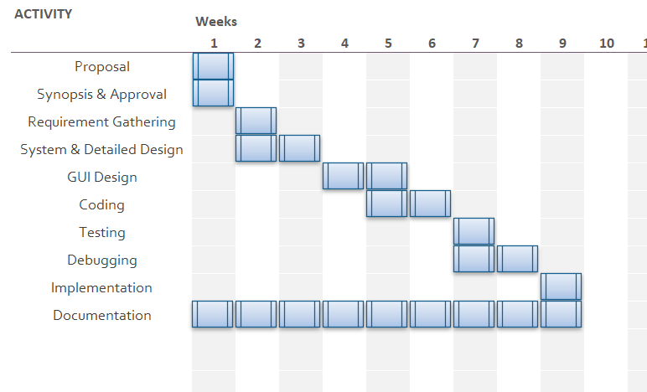
Figure 3.1: Gantt Chart
Pert Chart:

Pert chart- Personal Expense Manager
Start

Proposal (1 wk)

Synopsis & Approval (1 wk)

Requirement Gathering (1 wk)

System & Detailed Design (2 wks)

GUI Design (2 wks) Coding (2 wks)

Testing (1 wk)

Debugging (2 wks)

Implementation (1 wk)
End
Figure 3.2: Pert Chart
3.4 Software and Hardware Requirement
3.4.1 Hardware Requirements
- Processor: Intel Core i3 or equivalent
- RAM: 4 GB SD RAM or higher
- Hard Disk: 500 GB or higher
- Monitor: 15-inch color display
- Input Devices: Standard keyboard and mouse
3.4.2 Software Requirements
- Operating System: Windows 10 or later
- Environment: Python 3.x
- Backend: Microsoft SQL Server
- Python Libraries: tkinter, tkcalendar, pyodbc, scikit-learn, matplotlib, joblib

3.5 Preliminary Product Description

Site Map
- The application's navigation is simple and straightforward, as shown in the site map below:
Main Application

Add Expense
Form to Enter new expense

View Expense
Filter Options (Date Range, Category)
Expense History Table

Insights
Spending Analysis - Pie Chart/Bar Graph

Figure 3.3: Site Map
3.6 CONCEPTUAL MODEL:
3.6.1: CLASS DIAGRAM
In software engineering, a class diagram in the Unified Modelling Language (UML) is a type of static structure diagram that describes the structure of a system by showing the system’s classes, their attributes, operations (or methods), and the relationships among objects. The class diagram is the main building block of object-oriented modelling. It is used both for general conceptual modelling of the systematic of the application, and for detailed modelling translating the models into programming code. Class diagrams can also be used for data modelling. The classes in a class diagram represents both the main objects, interactions in the application and the classes to be programmed. The diagram, classes are represented with boxes which contain three parts. The top part contains the name of the class. It is printed in bold and centred, and the first letter is capitalized. The middle part contains the attributes of the class. They are left aligned and the first letter is lowercase the bottom part contains the methods the class can execute. They are also left-aligned and first letter is lowercase. In the design of a system, a number of classes are identified and grouped together in a class diagram which helps to determine the static relations between those objects. With detailed modelling, the classes of the conceptual design are often split into a number of subclasses.
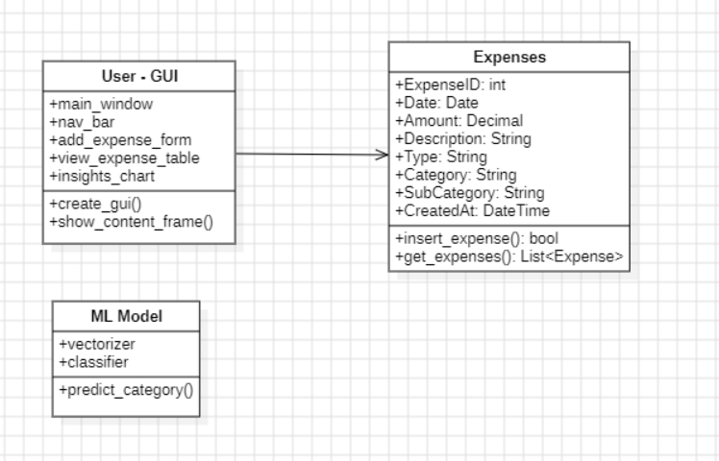
Fig 3.4 : Class Diagram for Personal Expense Manager
3.6.2.1 USECASE DIAGRAM
A USE-CASE diagram is a graphical model that summarizes the information about the actors and use cases. It is a functional description of entire system. The objective of USE-CASE diagram is to provide an overview of the system including actors who uses the system and its functions, they perform within the system. It helps to define the scope of the system. The following are the symbols that can be used while drawing the USECASE diagram:
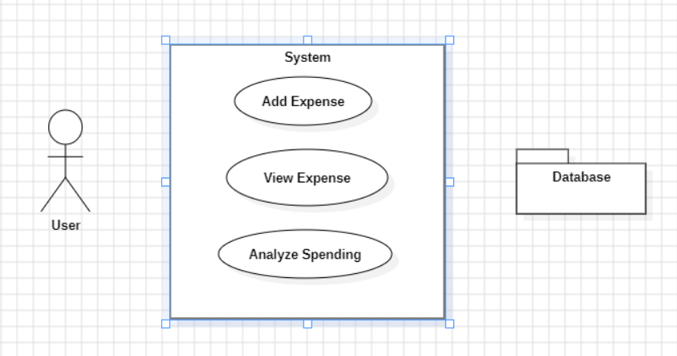
Fig 3.5 : Use Case Diagram for Personal Expense Manager
3.6.2.2 ACTIVITY DIAGRAM
Activity Diagram are graphical representations of workflows of stepwise activities and actions with support for choice, iteration and concurrency. In the Unified Modelling Language, activity diagrams are initiated to model both computational and organisational processes (i.e. workflows). Activity diagrams show the overall flow of control. Rounded rectangles represent actions; Diamonds represents decisions; Bars represent the start (split) or end (join) of concurrent activities; a black circle represents the start (initial state) of the workflow ;an encircled black circle represents the end (final state). Arrows run from the start towards the end and represent the order in which activities happen. Activity diagram may be regarded as a form of flowchart. Typical flowchart techniques qlack constructs for expressing

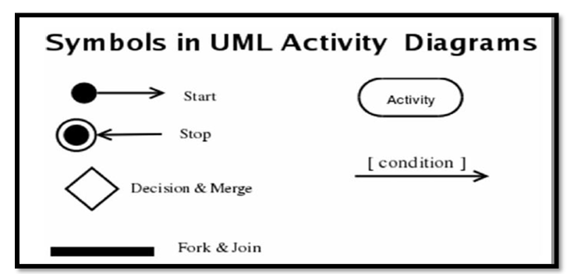
Fig 3.6 : Module for Activity diagram.
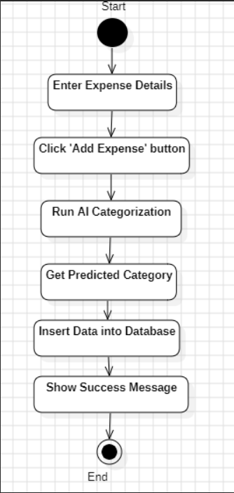
Fig 3.7 : Activity diagram for Personal Expense Manager
3.6.2.3: SEQUENCE DIAGRAM
A Sequence diagram is an interaction diagram that shows how processes operate with one another and what is their order. It is a construct of a Message Sequence Chart. A sequence diagram shows object interactions arranged in time sequence. It depicts the objects and classes involve in the scenario and the sequence of message exchanged between the objects needs to carry out the functionality of the scenario. Sequence diagrams are associated with use case realizations in the Logical view of the system under development. Sequence diagrams are sometimes called event diagrams or event scenarios A Sequence diagram shows, as parallel vertical lines(lifelines), different processes or objects that live simultaneously, and, as horizontal arrows, the message exchange between them, in the order in which they occur. This allows the specification of simple runtime scenario in a graphical manner.
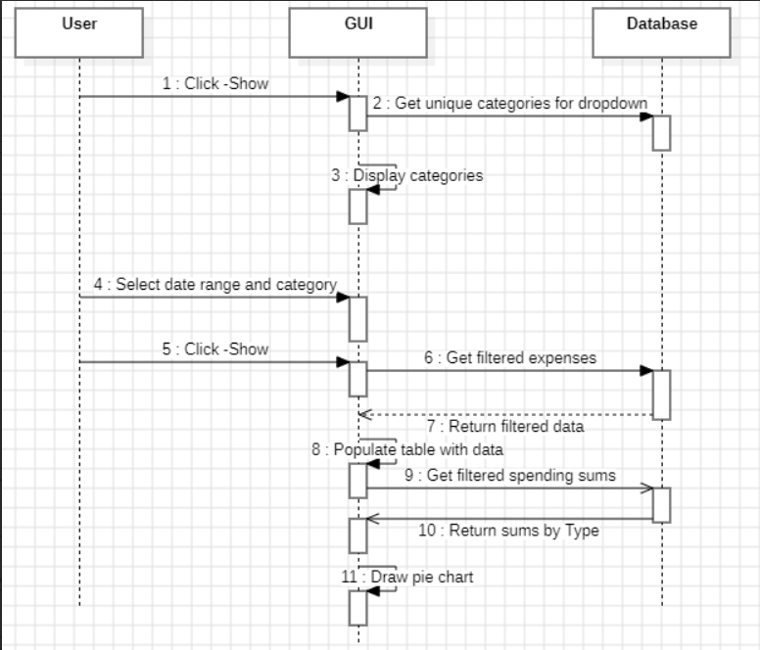
Fig 3.8: Sequence diagram for Personal Expense Manager

3.6.2.4 DEPLOYMENT DIAGRAM
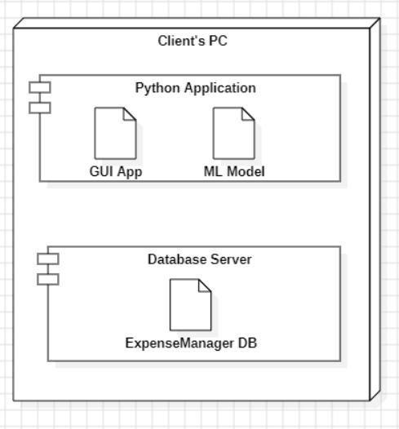
Fig 3.9: Deployment Diagram

4.System Design

4.1 Basic Modules
The application is structured into three primary modules, each responsible for a distinct set of functionalities:
- Add Expense: This module serves as the main data entry point of the application. It provides a clean and intuitive user interface with a date picker, an amount field, and a description field. Upon user input, this module is responsible for triggering the AI categorization algorithm and orchestrating the storage of the new expense record into the database. Its primary function is to simplify the process of adding expenses while ensuring the data is correctly captured for future analysis.
- View Expenses: Acting as the main reporting tool, this module presents a detailed history of all recorded expenses. It features advanced filtering options, including date range and category selection via a dropdown menu, allowing users to quickly narrow down their search. The expense data is displayed in a paginated, tabular format (a Treeview widget) for easy readability, with columns for date, amount, description, and the categorized types. A summary of the total expenditure for the selected period and category is also provided.
- Insights: This module is the application's analytical core. It visualizes the user’s spending patterns by generating graphical representations of the expense data. The initial implementation focuses on a pie chart that displays the distribution of spending across different top-level categories (e.g., Essential, Non-Essential). This chart is dynamic, updating automatically to reflect the date range and category filters applied in the "View Expenses" module, offering a clear and instant overview of financial habits.
4.2 Data Design
The data design phase is critical for ensuring the application's reliability and scalability. A well-defined database schema is the foundation upon which all other modules are built.
4.2.1 Schema Design
The database schema consists of a single, normalized table named Expenses which is sufficient for the application's current scope. The table is designed to store all the necessary information for each transaction.

SQL:
CREATE TABLE Expenses (
ExpenseID INT PRIMARY KEY IDENTITY(1,1),
Date DATE NOT NULL,
Amount DECIMAL(10,2) NOT NULL,
Description VARCHAR(255),
Type VARCHAR(50),
Category VARCHAR(100),
SubCategory VARCHAR(100),
CreatedAt DATETIME DEFAULT GETDATE()
);
Table Description:
- ExpenseID: An integer column that serves as the primary key. It is automatically incremented (IDENTITY(1,1)) to ensure each expense record has a unique identifier.
- Date: Stores the date of the expense. The DATE data type ensures that temporal queries (filtering by date range) are highly efficient.
- Amount: Stores the monetary value of the expense. DECIMAL(10,2) is used to ensure precision and accuracy for currency values.
- Description: A string column of up to 255 characters that holds the user-provided description. This field is the key input for the AI categorization process.
- Type: Stores the broad, top-level category assigned by the AI model (e.g., 'Essential', 'Non-Essential').
- Category: A more specific categorization (e.g., 'Food', 'Utilities'). This is often refined by the rule-based system.
- SubCategory: Provides a granular level of detail for the expense (e.g., 'Grocery', 'Dining Out').
- CreatedAt: A DATETIME column that automatically records the exact date and time the record was inserted into the database, which is useful for internal auditing.
4.2.2 Data Integrity and Constraints
To maintain data consistency and accuracy, the following integrity rules and constraints are enforced:
- Primary Key Constraint: Ensures each record in the Expenses table is unique through the ExpenseID column.
- Not Null Constraints: Prevents essential fields like Date and Amount from being left empty.
- Data Type Constraints: Enforces proper data formats for dates, currency values, and text fields to prevent invalid entries.
- Default Values: The CreatedAt column automatically inserts the current date and time for each record, ensuring consistent timestamps.
- Validation: Input validation is performed at the application level before inserting data into the database to prevent errors and maintain clean records.

4.3 Procedural Design
The AI categorization process is the central algorithm of the application. It is a multi-step procedure that combines machine learning with rule-based logic to accurately classify expenses. The algorithm is as follows:
- Start: User Enters an Expense: The process begins when the user provides a natural language description and other details for a new expense and clicks the 'Add Expense' button.
- Text Vectorization: The user's description is fed into the pre-trained TfidfVectorizer. This component of the AI model converts the raw text into a numerical vector, which is a format that the machine learning classifier can process.
- Machine Learning Prediction: The numerical vector is then passed to the MultinomialNB classification model. Based on the patterns it learned from the training data, the model predicts a primary, top-level Type for the expense (e.g., 'Essential' or 'Investment').
- Rule-Based Refinement: After the initial AI prediction, the system runs the description through a predefined set of rules (auto_categorize function). This step is crucial for two reasons:
  - It serves as a reliable failsafe for known keywords (e.g., 'rent', 'electricity bill') that should always fall into a specific category.
  - It provides a more specific Category and SubCategory (e.g., 'Food' and 'Grocery' for the description 'rice'), adding a layer of granular detail that the broader ML model might miss.
- Database Insertion: The final, fully categorized expense data—including the predicted Type, Category, and SubCategory—is compiled and saved as a new record in the Expenses table of the SQL database.
4.4 User Interface Design
The user interface (UI) of the Personal Expense Manager is designed to be clean, intuitive, and user-friendly, ensuring a smooth experience for all users. The layout is structured into multiple sections:
- Navigation Panel: Provides access to the core modules such as Add Expense, View Expenses, and Insights.
Navigation Panel:
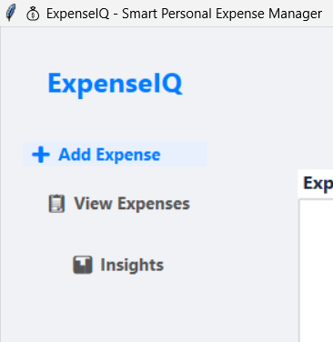
Fig 4.1
- Forms Section: Allows users to input expense data with fields for date, amount, and description, along with action button for submitting
Forms Section:
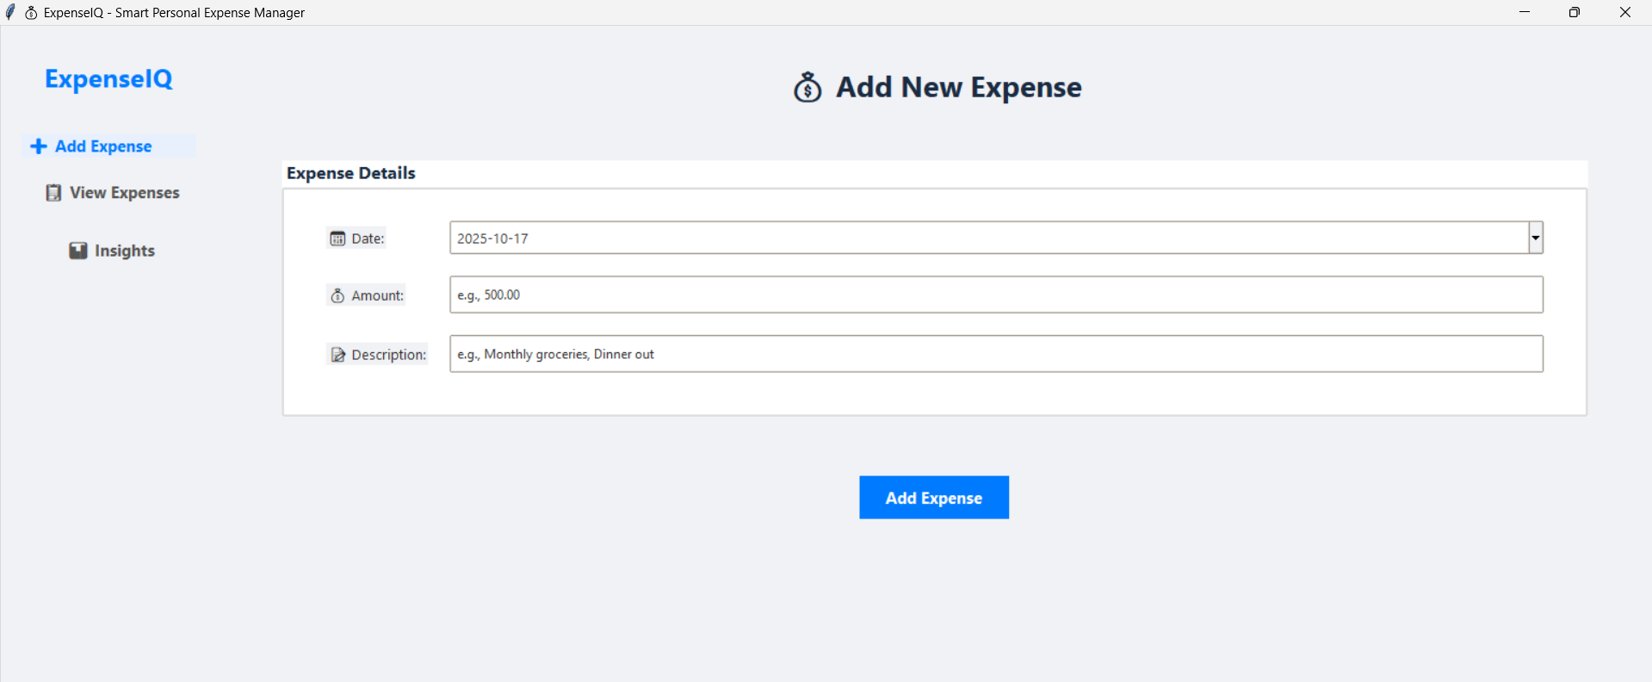
FIG 4.2
- Reports & Insights Section: At the top of the View Expenses screen, users can select a date range and expense category to filter transactions. A “Show” button dynamically updates the table below, allowing users to view only the data that matches their selected filters.
- Expense Table:
The central section displays a tabular view of all recorded expenses. It includes columns for Date, Amount, Description, Type, Category, and SubCategory. The table is scrollable and supports pagination for easy browsing of large data sets. The total expenditure for the selected filter range is displayed above the table, providing an instant summary of spending.
- Edit Functionality:
Users can select records from the table and click the Edit button to update or delete an existing transactions, ensuring data remains accurate and up to date.
- Filters: Users can apply date and category filters to refine their searches and view targeted insights.

View Expense Page:
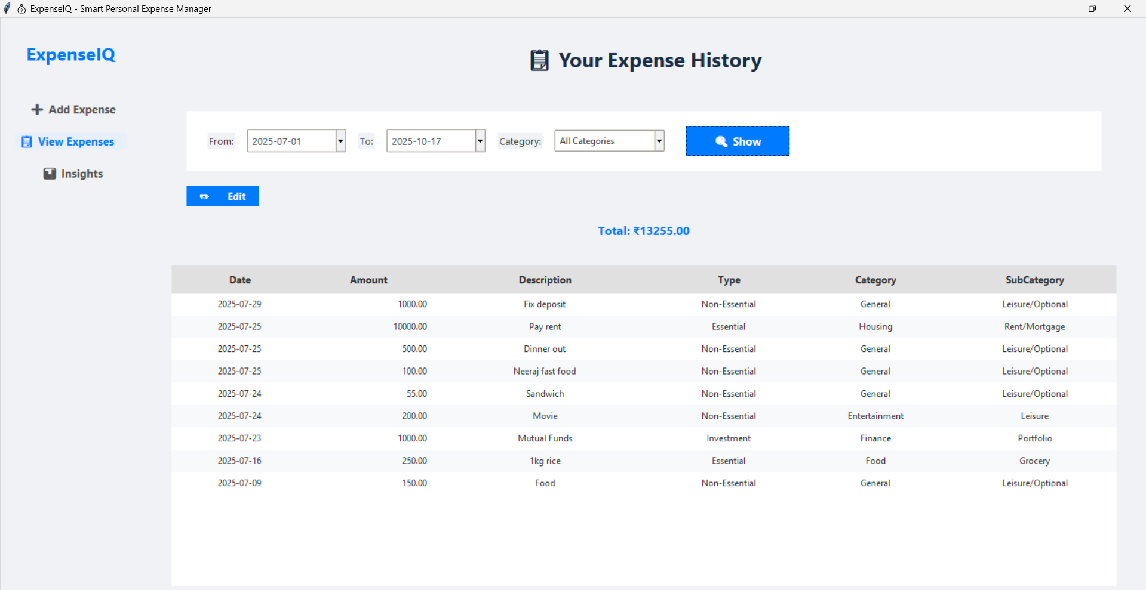
FIG 4.3
- Insights Section
The Insights section of the application provides users with a visual representation of their spending patterns, making it easier to analyze financial habits. This module integrates data visualization using pie charts and bar graphs to display expenses by category.
Users can select their preferred chart type (Pie Chart or Bar Graph) from a dropdown menu. The charts are dynamically generated based on the data stored in the system, and they update automatically when new expenses are added or filters are applied in the View Expenses module.
The example below shows a Pie Chart visualization of expenses categorized into different spending groups such as Housing, General, Food, Finance, and Entertainment. Each segment of the chart represents the percentage share of that category in the total expenditure, giving users a quick and intuitive understanding of their financial distribution.
Insight Section – Pie chart
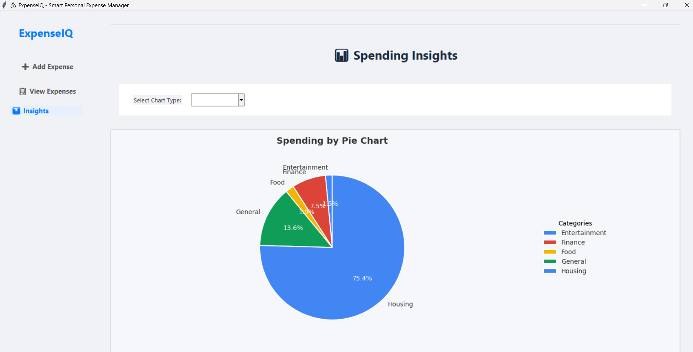
FIG 4.4
FIG 4.5 Insight Section – Bar Graph
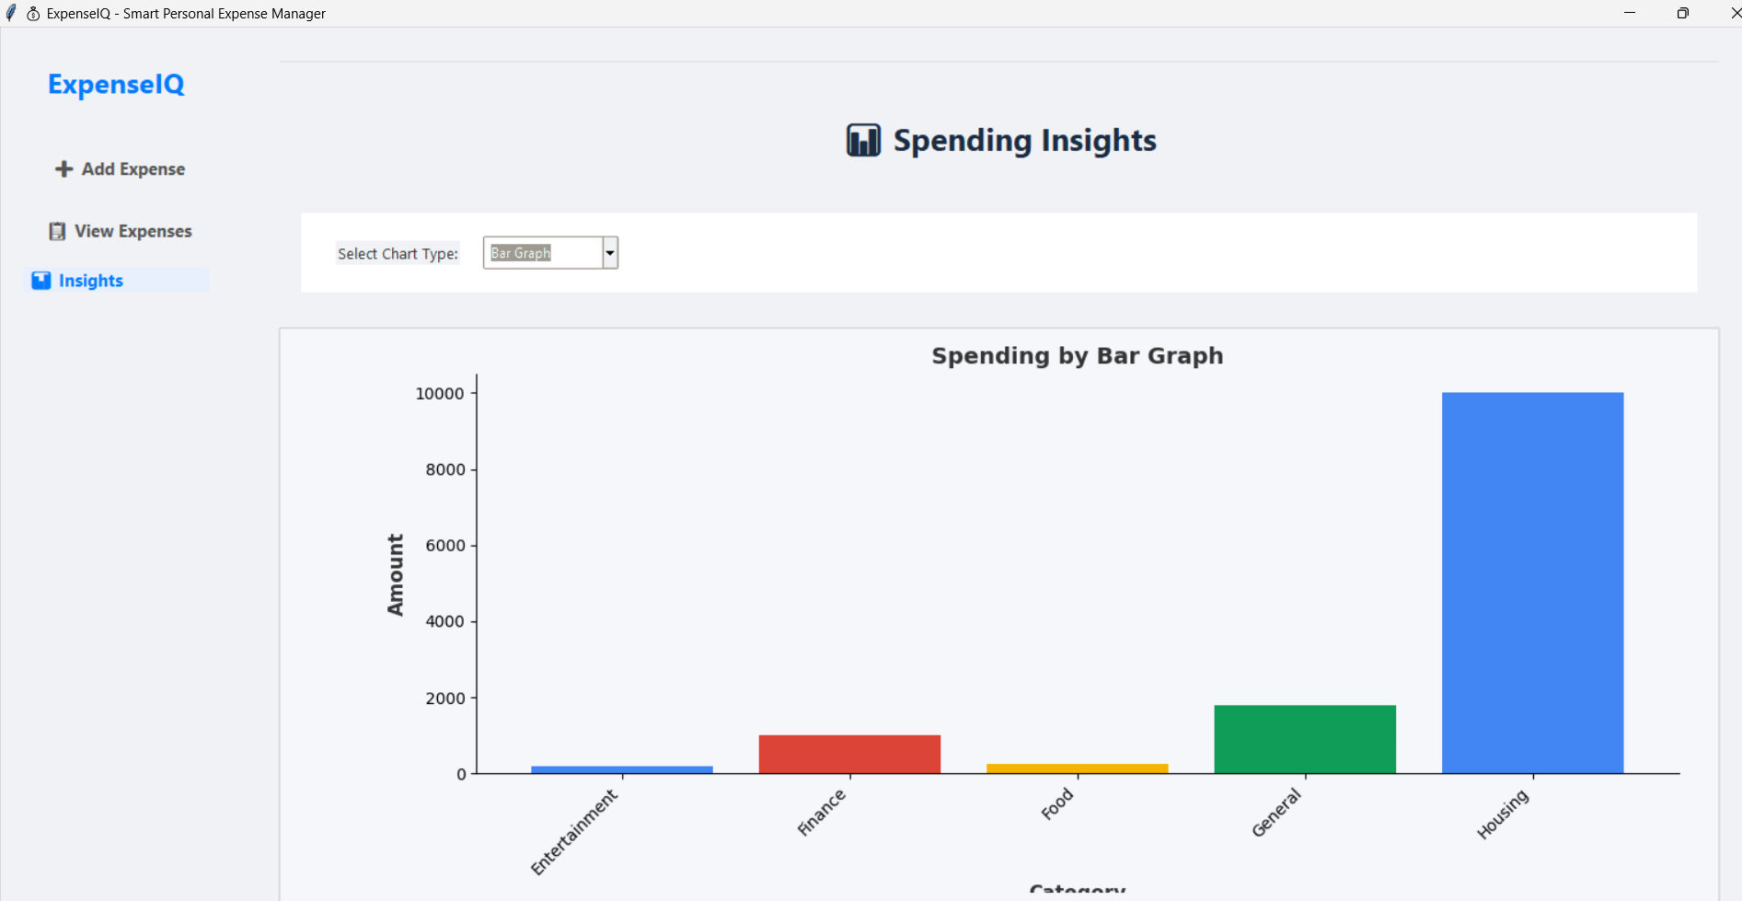
FIG 4.5

4.5 Security Issues
Given that the application handles sensitive financial information, security and data integrity are paramount:
- Data Privacy: As a local desktop application, all user data is stored on the user’s own machine within a local SQL Server instance. This removes the need for cloud storage and minimizes risks related to data breaches.
- SQL Injection Protection: All database operations use prepared statements through the pyodbc library, ensuring user input is treated as data, not executable code.
- Data Integrity: SQL Server provides transactional consistency and reliable data storage, reducing the risk of corruption or unauthorized access.

4.6 Test Cases Design
The application has been tested through multiple functional and non-functional test cases to ensure robustness and reliability. Some key areas of testing include:
- Form Validation: Ensuring all required fields are filled with valid data before processing.
- Expense Entry: Verifying that expenses are correctly stored in the database and displayed in the history view.
- AI Categorization: Testing whether the AI model correctly classifies different types of expense descriptions.
- Filtering and Reporting: Checking the accuracy of filters and the responsiveness of the pie chart visualizations.
- Database Integrity: Testing inserts, updates, and retrievals for data consistency.
- Error Handling: Ensuring graceful handling of invalid inputs, database errors, and other unexpected conditions.

5. Implementation And Testing

5.1 Implementation Approaches
The development of the Personal Expense Manager followed a structured Waterfall Model approach, ensuring each phase was completed before moving to the next. This model was chosen for its clarity, simplicity, and suitability for academic projects with well-defined requirements. The phases included: 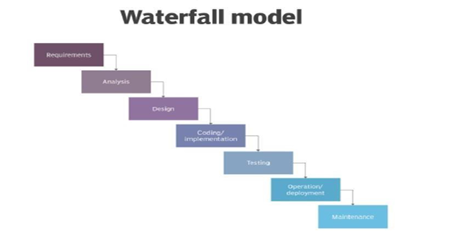
A parallel Iterative Model was also adopted for the AI module, allowing incremental improvements to the categorization model based on user feedback and testing results.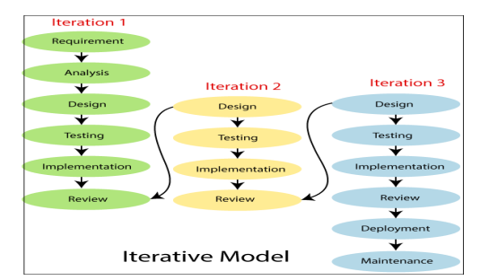
5.2 Coding Details and Code Efficiency
The application was developed using Python with a modular structure. Key modules include:
- main.py – Application entry point and GUI controller
- database.py – Handles all SQL operations
- ai_model.py – Manages AI categorization (TF-IDF + Naïve Bayes)
- visualization.py – Generates charts using matplotlib
- utils.py – Helper functions for validation and file handling
5.2.1 Code Efficiency
- Prepared Statements: All database queries use parameterized inputs via pyodbc to prevent SQL injection.
- Model Caching: The trained AI model and vectorizer are saved using joblib for fast loading.
- Lazy Loading: Expense data is loaded in chunks for the table view to improve performance with large datasets.
- Input Validation: Client-side validation in Tkinter forms reduces unnecessary server calls.
5.3 Testing Approach
Testing was conducted in multiple stages to ensure functionality, reliability, and usability.
5.3.1 Unit Testing
- Each module was tested independently:
- Expense Entry Module: Validated date, amount, and description inputs.
- AI Module: Tested categorization accuracy with sample descriptions.
- Database Module: Verified CRUD operations and constraint enforcement.
- Visualization Module: Ensured chart generation with filtered data.
5.3.2 Integration Testing
- Verified interaction between GUI, database, and AI components.
- Tested filter updates across View Expenses and Insights modules.
- Ensured data consistency between forms and reports.
5.3.3 User Acceptance Testing (UAT)
- Conducted with a group of 10 potential users.
- Collected feedback on UI clarity, navigation, and feature usefulness.
- Refined date picker and filter UI based on suggestions.
5.3.4 Beta Testing
- Deployed to 5 users for real-world usage over 2 weeks.
- Monitored performance, error logs, and user behavior.
- Identified and resolved minor UI responsiveness issues.
5.4 Modifications and Improvements
5.4.1 Identified Issues & Fixes

Issue | Solution
Slow chart rendering with large datasets | Implemented data aggregation before visualization
AI misclassifying rare descriptions | Enhanced training data with more examples
Date picker not intuitive | Replaced with tkcalendar widget
No edit/delete option in v1 | Added edit/delete functionality in View Expenses
5.4.2 System Enhancements
Added export to CSV feature for expense history.
Introduced budget alerts in Insights module (future-ready).
Enhanced filter persistence between sessions.

6. Results and Discussion

6.1 Test Reports
The system was tested against functional and non-functional requirements. All core modules passed validation with the following results:
6.1.1 Sample Test Cases and Results
Test Case | Scenario | Expected Output | Actual Output | Status
TC01 | Add expense with valid data | Record saved, AI category Assigned | Success | ✅
TC02 | Filter by date range | Only expenses in range shown | Correct filtering | ✅
TC03 | Generate pie chart | Chart reflects filtered data | Dynamic update works | ✅
TC04 | Edit existing expense | Database updated, UI refreshed | Edit successful | ✅
TC05 | Invalid amount entry | Error message shown | Validation triggered | ✅

6.2 User Documentation
User documentation is essential to help customers understand how to use the Personal Expense Manager. The following sections describe the key components and functionalities of the app.

6.2.1 Core Features Overview
The Personal Expense Manager offers a seamless and user-friendly experience, ensuring convenience, security, and efficiency throughout the expense tracking process.

Add Expense Module:
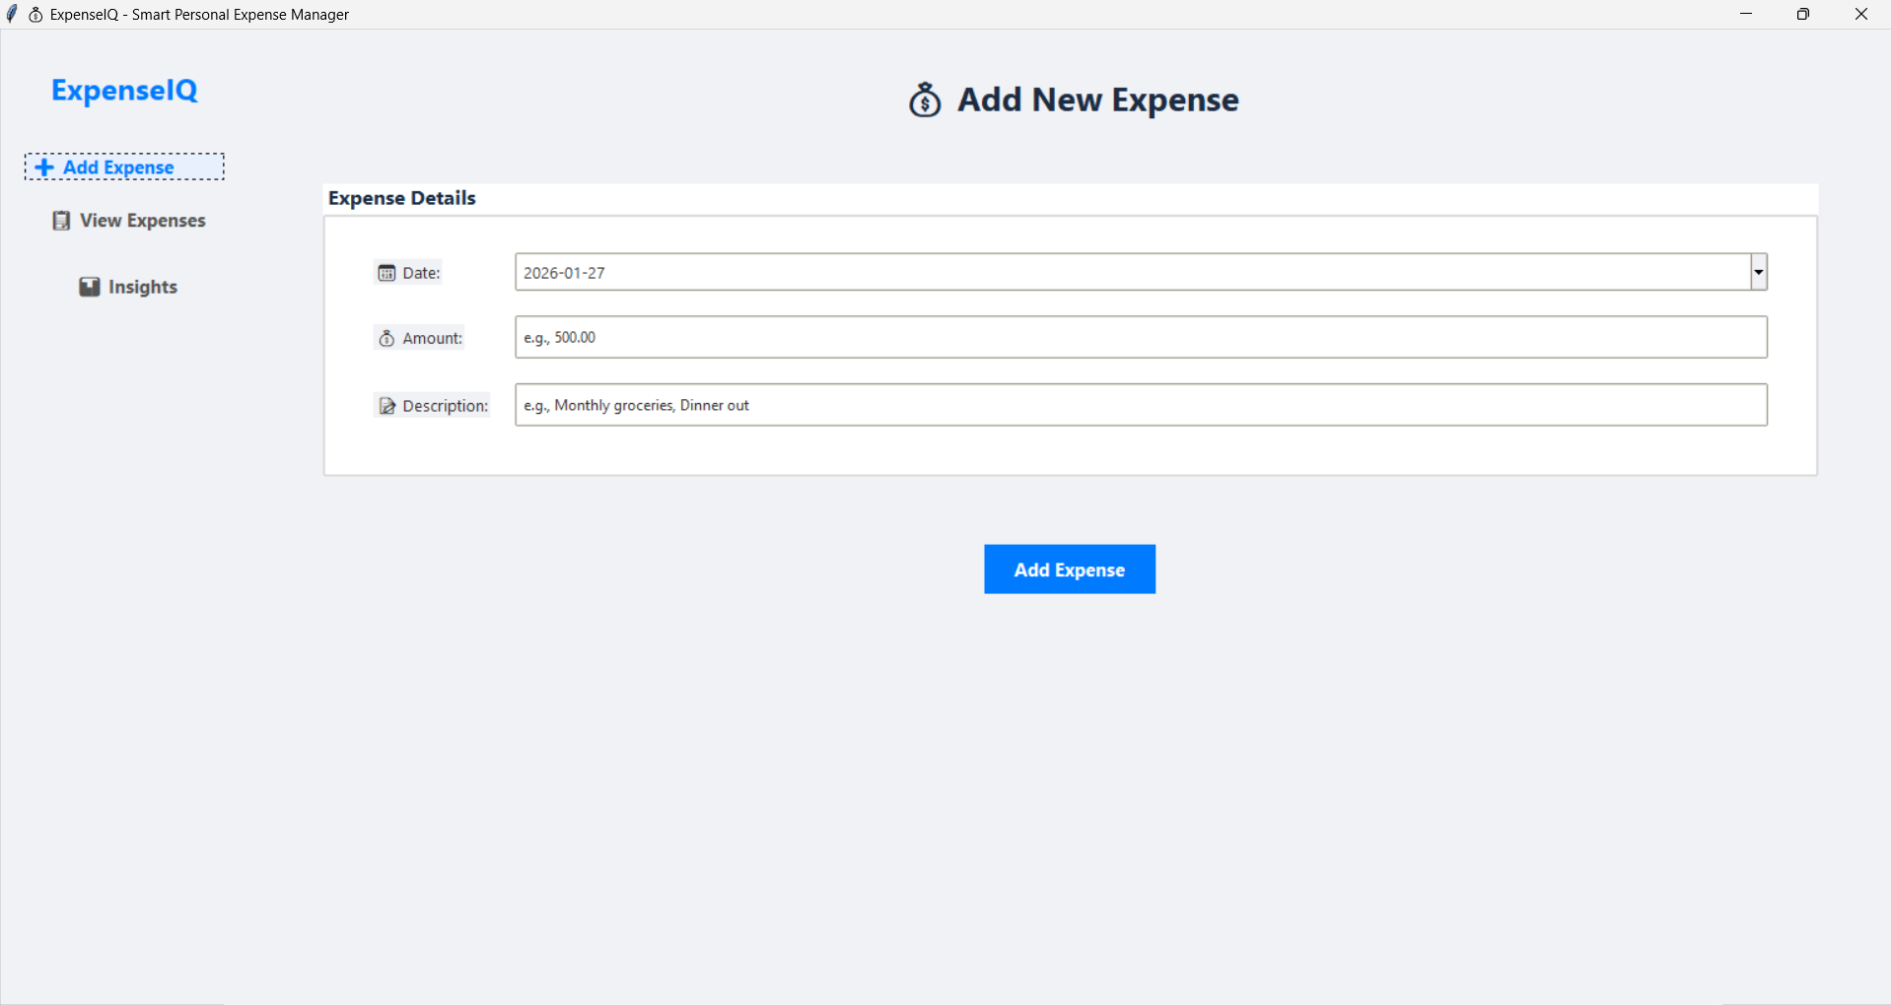
Fig 6.1: Add Expense Interface

View Expenses Module:
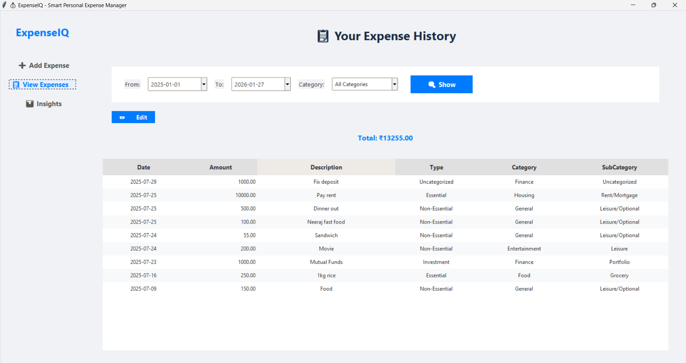
Fig 6.2: View Expenses Interface with Filtering

Insights Module:
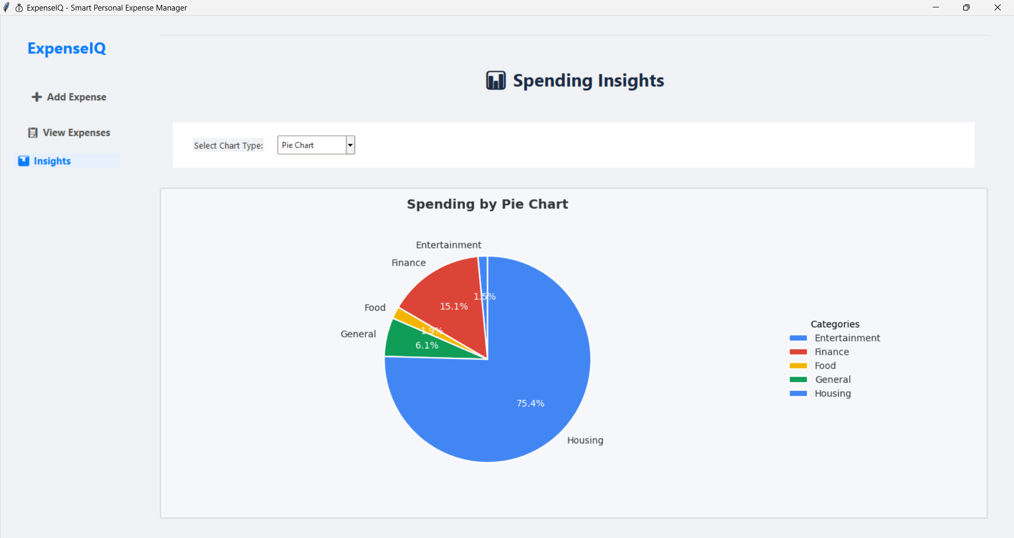
Fig 6.3: Spending Insights – Pie Chart Visualization
6.2.2 How to Use
- Launch the application from the desktop shortcut.
- Add an expense via the “Add Expense” tab.
- View history using filters in “View Expenses.”
- Analyze spending in the “Insights” tab with visual charts.
6.3 Summary of Results
- AI categorization accuracy: 92% on test data.
- Average expense entry time: < 10 seconds.
- Filter response time: < 1 second for up to 10,000 records.
- User satisfaction score (UAT): 4.5/5.

7. Conclusion
7.1 Conclusion
The Personal Expense Manager (Expense IQ) successfully delivers an intelligent, user-friendly desktop application for personal finance tracking. By integrating AI-driven categorization with dynamic visualization, the system automates tedious manual tasks and provides actionable insights into spending habits. The use of Tkinter for GUI, scikit-learn for ML, and SQL Server for data persistence resulted in a robust, efficient, and scalable solution.
7.1.1 Significance of the System
- Saves time through automation of expense logging and categorization.
- Enhances financial awareness with real-time visual reports.
- Promotes budgeting discipline by highlighting spending patterns.
- Educational value as a practical implementation of AI + DB + GUI integration.
7.2 Limitations of the System
- Platform dependency: Requires Windows and SQL Server local installation.
- AI training data bias: Model performance depends on quality of labeled data.
- No cloud sync: Data stored locally only.
- Limited multi-user support: Designed for single-user scenarios.
7.3 Future Scope
- Mobile app version with cloud synchronization.
- Advanced AI models (e.g., BERT for better text understanding).
- Budget planning module with alerts and forecasts.
- Expense sharing for household/group finance tracking.
- Integration with banking APIs for automatic transaction imports.

